SeaSpace TeraScan GOES Multispectral Animations

Kathryne Burton
GOES Team Member
ECSU
Elizabeth City, NC
kaburton303@students.ecsu.edu
Michael Cobb
GOES Team Member
ECSU
Elizabeth City, NC
mrcobb948@students.ecsu.edu
Khaliq Satchel
GOES Team Member
ECSU
Elizabeth City, NC
kjsatchell026@students.ecsu.edu
Dr. Malcolm LeCompte, Ph.D.
Archaeology Team Mentor
ECSU
Elizabeth City, NC
Malcolm.lecompte@cerser.ecsu.edu

James Headen Andrew Brumfield
GOES Team Member GOES Team Member
ECSU ECSU
Elizabeth City, NC Elizabeth City, NC

jheaden@students.ecsu.edu abrumfield12ecsu@gmail.com

Dr. Linda Hayden, Ph.D. Principal Investigator
Elizabeth City State University
1704 Weeksville Road, Box 672
Elizabeth City, North Carolina 27909

Abstract-Installation of the two SeaSpace Terascan Geostationary Operational Environmental Satellite (GOES) receivers in July, 2013 provides ECSU’s CERSER laboratory with a capability to capture and generate the most current image data available of the Earth’s Western Hemisphere environment. The data is provided in an operational mode defined by the limitations of the GOES scanning imaging system. The GOES system operations are scheduled by the National Oceanic and Atmospheric Administration (NOAA) to provide various obligated environmental products, primarily to support numerical meteorological prediction services to different regions of the Western Hemisphere.
A principal advantage of any remote sensing system located in Geostationary orbit lies in the ability to create ‘loops’ or animations that reveal changes that occur in the Earth’s environment. The GOES imaging system or baseline imager, provides scanned images in five (5) wavelength bands, each of which provides different meteorological information to weather forecasters: Channel 1: Visible (panchromatic, 0.52 to 0.71 μm), Image sequences provide high spatial resolution (1 km/pixel) animations of daytime cloud cover and wind velocities, Channel 2: Short Wavelength Infrared (3.73 to 4.07 μm), Image sequences provide night cloud cover animations and wind velocities, Channel 3: Middle-Wavelength Infrared (5.80 to 7.03 μm), Image sequences provide water vapor content animations and velocities, Channel 4: long-wavelength or thermal Infrared (10.20 to 11.20 μm), Image sequences provide day and night cloud cover and water vapor animations and wind velocities and sea surface temperatures, and Channel 6: long-wavelength Infrared (13.00 to 13.70 μm), Image sequences provide day and night cloud cover animations and cloud heights. The spatial resolution of all Infrared channels is 4 km/pixel.
NOAA maintains two operational GOES systems in orbit; one at 75° West Longitude provides environmental coverage to the East Coast and Western Atlantic Ocean while the other at 135° West Longitude provides coverage to the west coast and eastern Pacific Ocean. Data from the two operational GOES satellites and other Remote sensing satellites can be combined to create new data products that may have utility in a number of specialized applications. The first step in creating innovative data products was to learn the functionality of the SeaSpace Terascan system.
The GOES Data Products Team learned how to create remote sensing data animations using the Terascan system. The objective was to create an animation of the visible disk of the Earth in 3 channels, most important will be creating animations at visible wavelengths and mid and one of the thermal IR channels.
Key Words— TeraScan, TeraScan Data Format (TDF), Geostationary Operational Environmental Satellite (GOES), GOES East, GOES West
Environmental and meteorological satellites can have their data automatically received by the integrated system known as TeraScan. TeraScan is a combination of hardware and software designed to process data from such satellites, turning the data received into images. TeraScan has a specific format known as TeraScan Data format (TDF) which makes it possible for the data to be viewed in a viewer titled TeraVision. The TDF files have the ability to be converted into picture products in numerous formats and styles. The picture formatted data can easily be shared throughout the network.

The system can be found in many different model types, each targeted at a specific satellite telemetry, nonetheless, each system is composed of hardware and software components. Some of the hardware components include: an antenna to obtain satellite reception, a receiver to tune the frequency to the correct frequency for a particular satellite, a frame synchronizer to divide the data into meaningful sections, Global Positioning System (GPS) to add a time and position variable to the antenna, as well as Uninterruptable Power Supply (UPS) to protect the system from surges, and to keep it running in the case of a power outage. The UNIX operating system serves as a foundation for the development of the software. The software for TeraScan incorporates: a set of reference files, daemons and services, and also graphical user interfaces (GUI’s) which all work in conjunction to allow the operator to effectively utilize the capabilities of the system. Over 600 command-line-functions are connected with this system providing assistance and ease when it comes to the aspects of data reception, and data processing.

The TeraScan system can be used with many different satellites. The system can be set-up to receive and process data from Polar-Orbiting satellites that use L/S- Band transmittance, Polar-Orbiting satellites that use X-Band transmittance, and it can even be utilized for Geostationary satellites that use L-Band transmittance. The sophistication of the system makes it possible to process raw satellite data, and it can even concentrate on a particular area of interest. Mathematical data interpretations can be applied to data, datasets can be managed, functions can be identified, and statistical calculations can be made using the TeraScan system. Overlays and pictures can be generated from the system, and such information can be exported to other systems.

GOES SYSTEM
TeraScan can be utilized in collaboration with GOES systems data. GOES stands for Geostationary Operational Environmental Satellite. GOES is a series of satellites owned and operated by the National Oceanic and Atmospheric Administration (NOAA). Once launched into orbit, these satellites stay on a specific longitude location and follow the Earth’s orbit without straying from its location, thus why they are called geostationary. There are five GOES satellite wavelength bands and each has its own capabilities that the others don’t have. The five are visible wavelength, shortwave IR wavelength, upper level water vapor, the first thermal IR, and the second thermal IR.
The first wavelength band is the visible wavelength is used for cloud coverage, pollution, and haze detection. It can also identify severe storms. This band is mostly used during the daytime because it doesn’t use infrared like some of the other bands. Its wavelength range is 0.52 to 0.72 micrometers and the spatial resolution is 1 kilometer.
The shortwave infrared wavelength is the second wavelength band that GOES uses. This wavelength is used for mostly nighttime observations but it can also be used for daytime observations. It can be used to identify fog as well as sea surface temperature at night. It can also be used to detect fires and volcanoes, night or day. During the daytime, this wavelength can be used to discriminate water clouds and snow or ice clouds. The wavelength ranges from 3.78 micrometers to 4.03 micrometers. The spatial resolution is 4 kilometers.
The third band is the upper level water vapor and its wavelength range is 6.47 to 7.02 micrometers. It estimates regions of mid-level moisture content and advection, the transfer of heat by the flow of a liquid, especially horizontally in the sea or atmosphere. This band also deals in tracking mid-level atmospheric motion. The spatial resolution of this wavelength band is 4 kilometers. The next wavelength band, which is the fourth, is a long wave thermal infrared wavelength. It deals with identifying cloud-drift winds, severe storms, and heavy rainfall. Its wavelength range is from 10.2 micrometers to 11.2 micrometers and the spatial resolution is 4 kilometers. The fifth and last wavelength band is the thermal infrared wavelength that is sensitive to water vapor. The identification of low-level moisture is one use of this band. Another use would be that it can determine sea surface temperature. And lastly it can detect airborne dust and volcanic ash. The wavelength range is 11.5 micrometers to 12.5 micrometers with the spatial resolution of 4 kilometers.

Goes consist of individual working components, among the working compartments is goes imager. The goes imager system has five channels: the first visible and the next four infrared. The Imager system monitors the earth’s radiant and solar reflected energy in each band pass. Using a mirror scan system in conjunction with a Cassegrain telescope, the Imager can provide accurate data as it repeatedly scans from east to west. The visible channel provides grayscale or panchromatic views through eight detectors. Each of the detectors has a square instantaneous field of view (IFOV) subtending 28 micro radians on a side.
From an altitude of 35,785 km, this provides a spatial resolution of 1 km pixel square instantaneous geometric field view. The next channels are infrared, which host 4 individual channels of: shortwave; moisture; long wave 1 and lastly long wave 2. Infrared imaging collects emitted thermal energy from an object. Using infrared imaging serves as a major benefit because it provides the ability to map specific elements of the earth that emit either cold or hot temperatures. It allows the four channels to map beyond what the natural eye can render. Unlike the visible channel, the infrared channels provide a great range of sight with 4km pixels and 8 km pixel field views.

Although it is positioned directly above the equator, the GOES system is currently governed by the National Oceanic and Atmospheric Administration (NOAA) while National Aeronautics and Space Administration(NASA) adheres to the designing and launching for the satellite. The benefits of having a geostationary satellite are the repeated field data views and the ability to monitor real time weather development. The disadvantage of geostationary satellites are the clearer resolution of the mapped objects. Two satellites make up GOES and they are: GOES east (goes 13) and Goes west (Goes 14). Goes east is located at 75 degrees west while goes west is located 135 degrees above the equator.
The GOES team used the TeraScan software in order to create a master from which three animations were made. Three full disc animations were created in order to show the real-time passes of the earth’s activity on three different channels; channel 1, channel 3, and channel 4. The first step necessary to create the animations was to create a master. TeraMaster was used to create a master which allowed a full disc image to be made and it permitted manipulations of the image such as controlling pixel size, number of pixels, type of overlays, and the style of the map image.
Figure 1: Screenshot of the full disk animation using Channel 1.
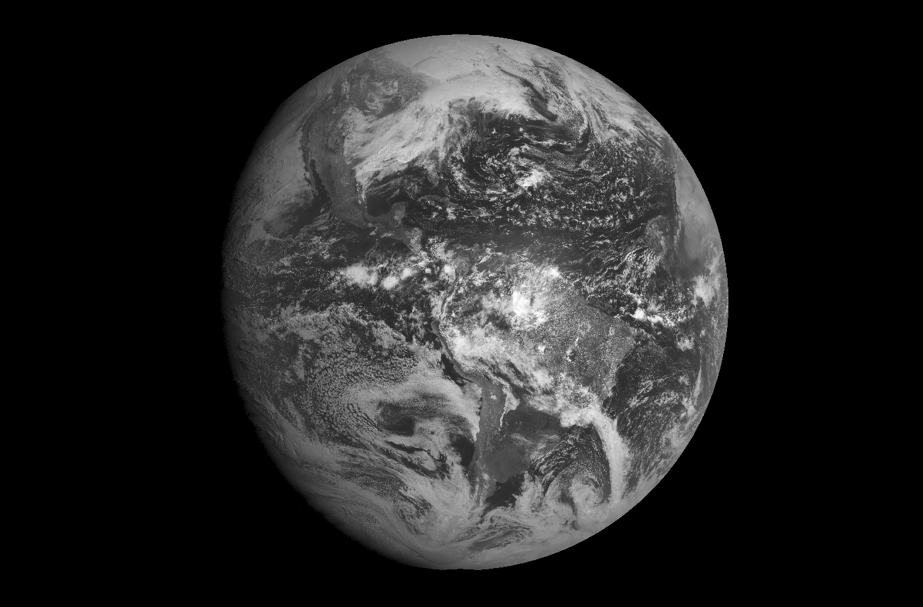

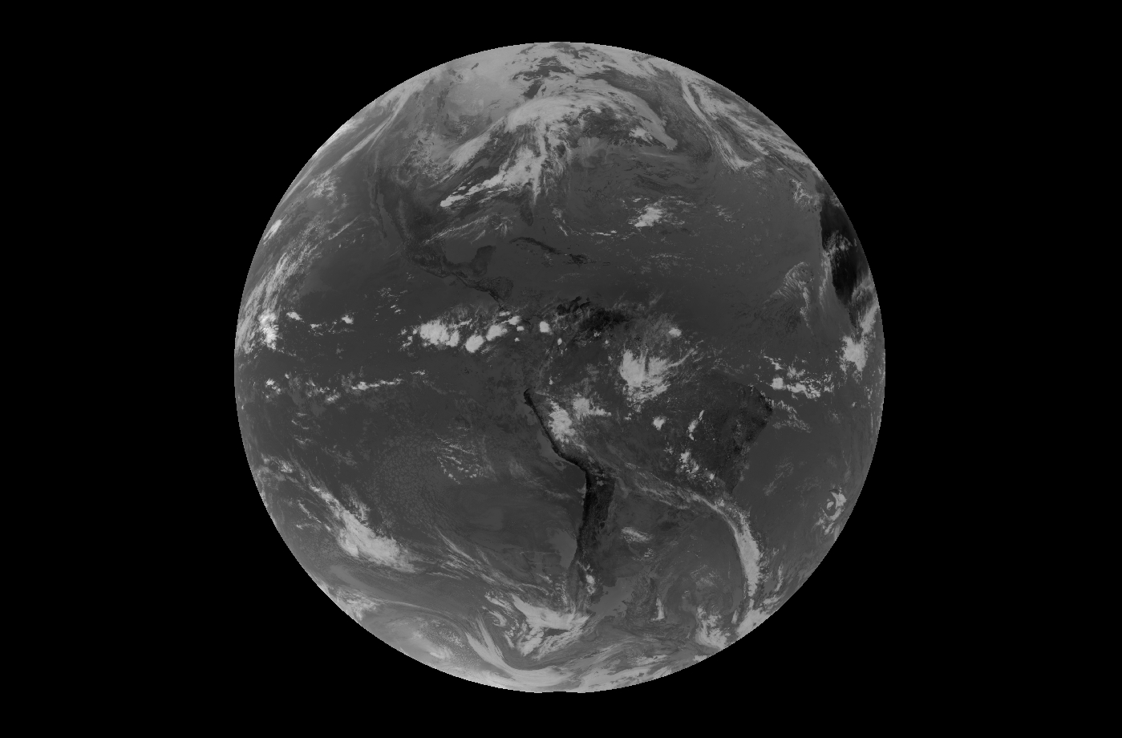
Figure 2:Screenshot of the full disk animation using Channel 2.

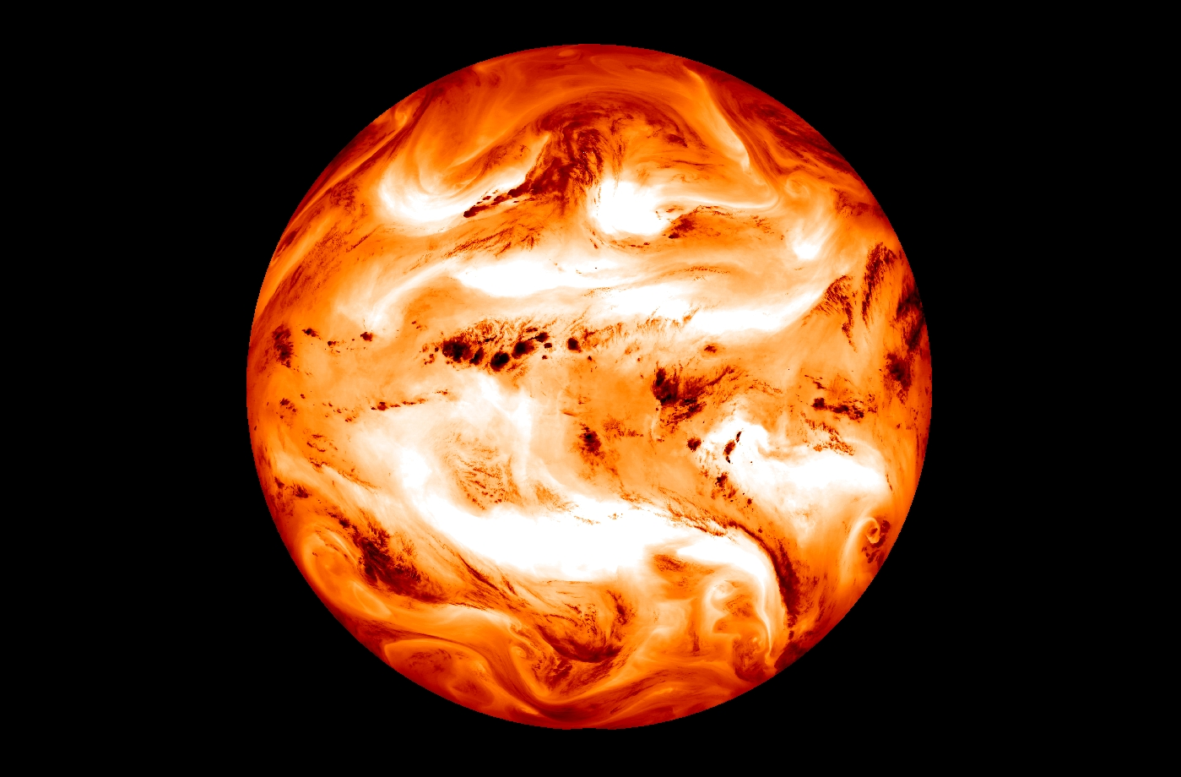
Figure 3: Screenshot of the full disk animation using Channel 3.

Conclusion and Future Work
The project opened up many different avenues that may be considered as a task for future work. The future work that most correlates with this research interest would be to use GOES east and Goes West collaboratively to obtain a single image. Using both satellites will permit a composite image to be developed by overlapping the imaging from both satellites.

References
- Geostationary Operational Environmental Satellite Program (GOES). Goddard Space Flight Center.
- "GOES-R Spacecraft". Geostationary Operational Environmental Satellite Program (GOES). Goddard Space Flight Center.
- Hill, Steve. "GOES-R Solar and Space Environment Data Products: Benefiting Users". Geostationary Operational Environmental Satellite Program (GOES). NOAA Space Weather Prediction Center.

